Demostration Report
Github link: https://github.com/Arpon7/ElevatorV2.0/tree/main

ElevatorV2.0 is a small project to explain how a lift (elevator) works. A four-story building is chosen as a test case.

The repository mainly has 3 parts:
- An interactive webpage: to comprehend the algorithm that is used to run the elevator system efficiently between floors.
- A wowki simulation: to demonstrate the firmware and hardware implementation
- A Python-based demo: for the data-logger (to enable predictive maintenance).

In the real world, an elevator system is generally PLC based. This is a distributed system with a main controller.

The key components are:
Control System: decides which floor to go to and in what order
Motor System: moves the elevator up and down
Safety System: ensures doors close, weight limits aren't exceeded
Call System: buttons inside and outside the elevator

Lots of hardware (with proper coordination) is required to build such a system. There is a motor drive to control the induction motor, a controller for user interactions, a safety and recovery system, a lighting and ventilation system, etc.

The control system plays the most important role in the smooth running of the elevator. A bare minimum setup is done using a simulation platform, Wokwi.

Link to the simulation: https://wokwi.com/projects/460287833026581505

Limitations of this simulation:
While the processor is busy executing one task, any other command gets disregarded. For example, if the lift is going from floor 0 to floor 2, any call from floor 3 will not register. Using a dedicated controller for the call buttons and then sending the requests on a priority basis to the main controller will solve the problem.
No safety features (such as IR sensors to prevent door shutdown if a movement is detected on the cab door rail during closing) are implemented.

Elevator Algorithm (SCAN):
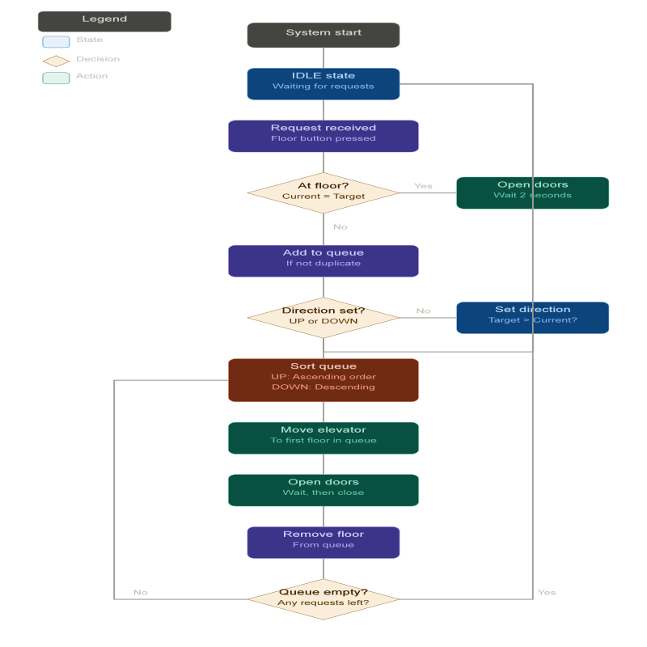
This elevator serves 4 floors (Ground, 1, 2, 3) using the SCAN algorithm, which moves in one direction serving all requests before reversing. for the floor sensing sensor, push buttons are used. In the real world, limit switches do the job. Wowki Simulation:

To understand the algorithm in an interactive way, this link can be visited: https://arpon7.github.io/InteractiveElevator-web/

The possible integration of AI:
The provided elevator.py file simulates these parameters with the help of a GUI and creates a .CSV file as a datalogger. In the real world, an SBC (single-board computer) or a custom board with enough memory can handle this. Even such a setup can communicate with a remote server (cloud).

Work In Progress (WIP):
As a stepping stone, this project is good. But the ultimate target is to build a product with features like Predictive Maintenance (PdM).

